Discovered anomalies

# Population of PowerTransformerEnd objects:

in LTDS EQ, every PowerTransformerEnd object is required to have the following attributes:

* cim:TransformerEnd.end Number
* cim:PowerTransformerEnd.b
* cim:PowerTransformerEnd.connectionKind
* cim:PowerTransformerEnd.r
* cim:PowerTransformerEnd.ratedS
* cim:PowerTransformerEnd.ratedU
* cim:PowerTransformerEnd.x
* cim:PowerTransformerEnd.earthingMethod

and it might have the following optional attribute:

* cim:PowerTransformerEnd.g

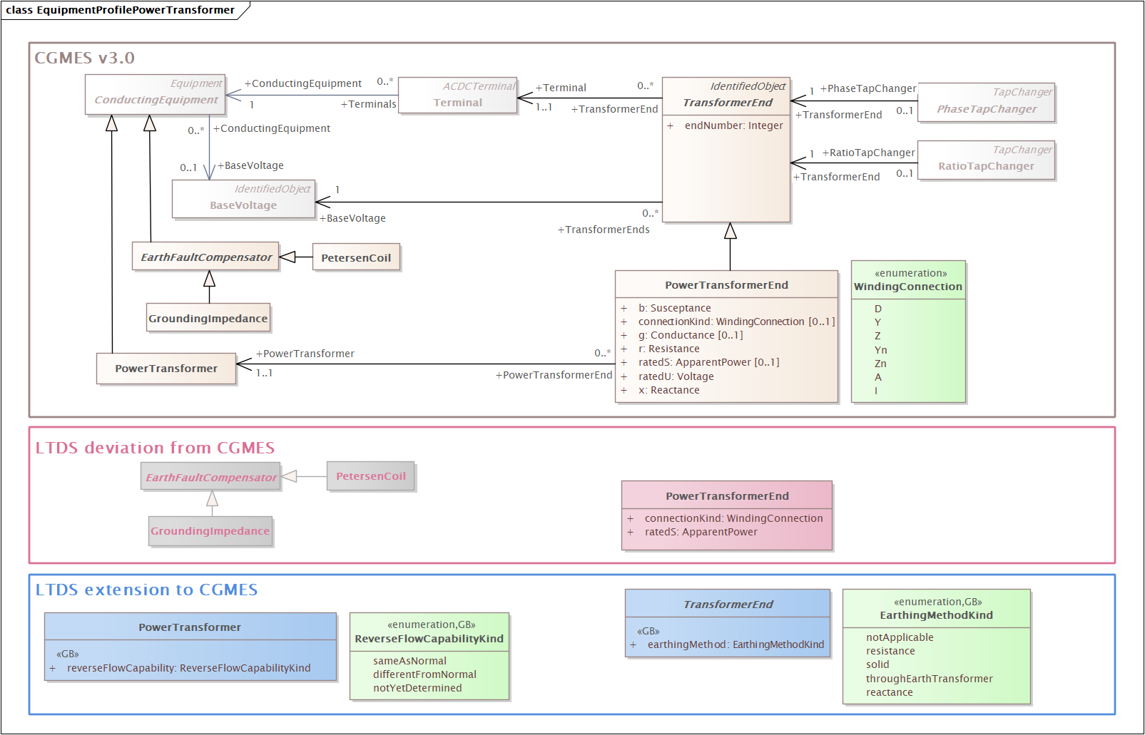

How does this – which requires .b, .r, .x and optionally .g for the lower-voltage winding of a 2-winding transformer – align with this section of -452?

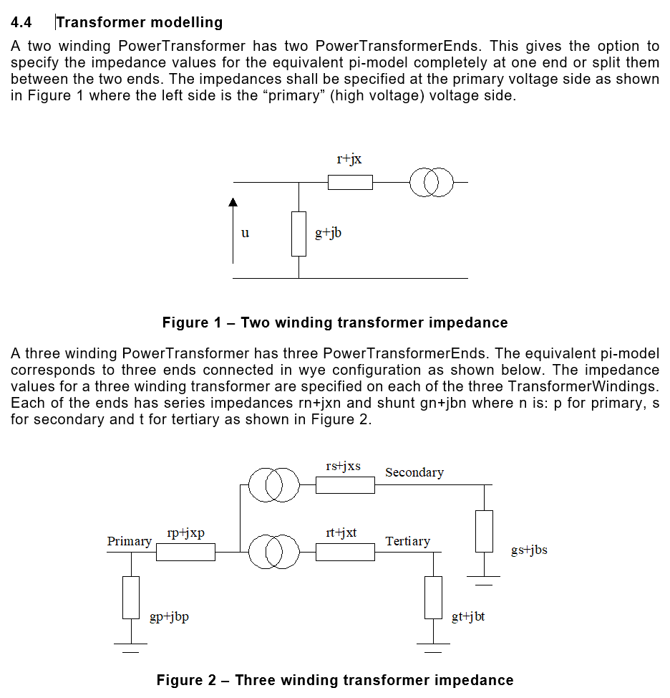

# ‘seasonal’ limits on Disconnector example

Since there is only one OperationalLimitSet for the Disconnector, its .validFrom and .validTo should be the same. This needs to be fixed in the LTDS Grid Modelling Annex 1: Grid Modelling Guidelines document.

